**East West University**

Name : Abdullah Al Mamun   
ID: 2013-1-60-021

Course title : Database System

Course code: CSE301  
Section: 1  
Exp. No: 06

Exp. Date: 30.06.15

**Class Work**

Table Creation**:**

create table employee(

ename varchar(20),

street varchar(20),

city varchar(20),

)

create table works(

ename varchar(20),

cname varchar(20),

salary numeric(9,3),

jdate datetime,

)

create table company(

cname varchar(20),

city varchar(20)

)

drop table company

create table manages(

ename varchar(20),

mname varchar(20)

)

Data insertation:

insert into employee values('Rahim','X','Dhaka');

insert into employee values('Mity','Y','Sylhet');

insert into employee values('Sabbir','z','Ctg');

insert into employee values('Babu','p','Dhaka');

insert into employee values('Toma','X','Bogra');

insert into employee values('Jabbar','X','Comilla');

insert into works values ('Rahim','First B.C',20000,'8/8/2008')

insert into works values ('Mitu','Small B.C',30000,'8/13/2008')

insert into works values ('Sabbir','Square Pharma',40000,'9/17/2008')

insert into works values ('babu','GP',50000,'12/31/2008')

insert into works values ('Toma','Square',35000,'10/10/2008')

insert into works values ('Jabbar','First B.C',15000,'4/4/2008')

insert into company values ('First B.C','Dhaka');

insert into company values ('Small B.C','Sylhet');

insert into company values ('Square Pharma','Ctg');

insert into company values ('GP','Rajshahi');

insert into manages values('Rahim','Sabbir');

insert into manages values('Mitu','Babu');

insert into manages values('Toma','Oronno');

insert into manages values('Salam','Jabbar');

**Ques: 1**

select cname from company where cname like '__'

output:

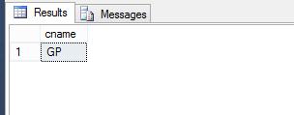

**Ques 2:**

select ename from employee where ename like '______%'

Output:

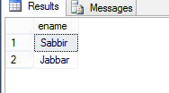

**Ques 3:**

select * from employee where ename like 's%'

output:

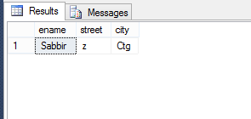

**Ques 4:**

select * from employee where ename like '%m'

output:

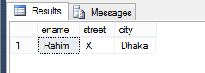

**Ques 5:**

select * from employee where ename like 'R%m'

output:

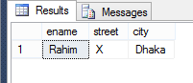

**Ques 6:**

select * from employee where ename like'J%'

output:

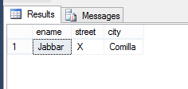

**Ques 7:**

select * from employee where ename like '%b%'

output:

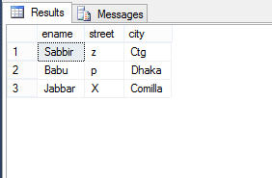

**Ques 8:**

select * from works order by salary asc

output:

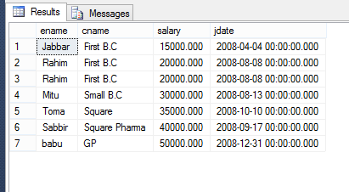

**Ques 9:**

select * from works order by salary desc

output:

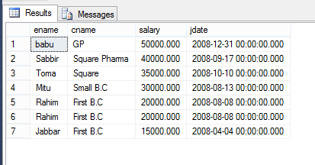

**Ques 10:**

select * from works order by salary asc,ename desc

output:

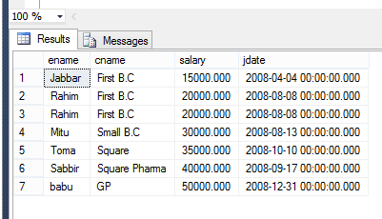

**Ques 11:**

select ename from works where cname='First B.C'

output:

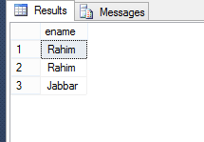

**Lab Exam**

Table Creation :

create table book(

ISBN int,

title varchar(20),

price int,

publisherid int

)

create table publisher(

publisherid int,

pname varchar(20),

paddress varchar(20)

)

create table author (

authorid int,

author_name varchar(20),

address varchar(20)

)

create table author_book(

ISBN int,

authorid int

)

Data Insertation:

insert into book values (4125,'abc',120,1);

insert into book values (7412,'databse',253,2);

insert into book values (3256,'network',183,1)

insert into book values (7456,'math',213,3);

insert into book values (7458,'physics',745,1);

drop table book

insert into publisher values (1,'narosa','dhaka');

insert into publisher values (2,'macgill','newyork');

insert into publisher values (3,'pearson','canada');

insert into publisher values (4,'alfred','delhi');

insert into author values (124,'asif','dhaka');

insert into author values (2354,'ana','newyork');

insert into author values (142,'devid','osaka');

insert into author values (1258,'jhon','canada');

insert into author_book values (4125,124);

insert into author_book values (7412,124);

insert into author_book values (3256,142);

insert into author_book values (7456,1258);

insert into author_book values (7458,142);

**Ques 1:**

select address from author where address like '_____'

Output:

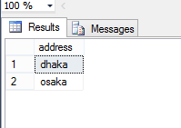

**Ques 2:**

select address from author where address like '______'

Output:

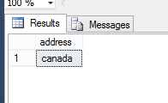

**Ques 3:**

select paddress from publisher where paddress like '______%'

Output:

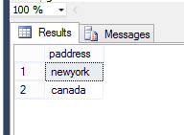

**Ques 4:**

select author_name from author where author_name like 'a%'

Output:

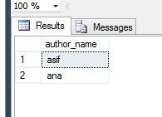

**Ques 5:**

select author_name from author where author_name like 'a%a'

Output:

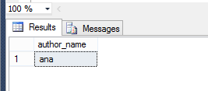

**Ques 6:**

select author_name from author where author_name like '%n'

Output:

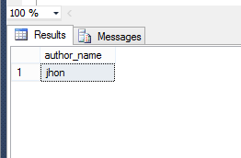

**Ques 7:**

select paddress from publisher where paddress like 'd%'

Output:

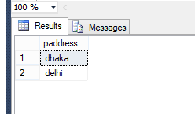

**Ques 8:**

select * from book order by ISBN asc

Output:

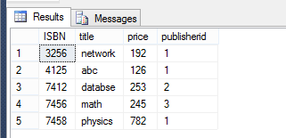

**Ques 9:**

select * from book order by ISBN desc

Output:

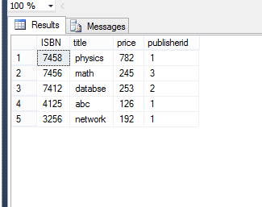

**Ques 10:**

select * from book order by price asc,ISBN desc

Output:

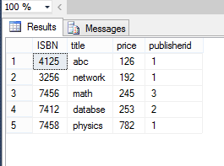

**Ques 11:**

update book set price=price*1.05 where publisherid in (select publisherid from publisher where pname='pearson')

select * from book

Output:

Before Update: After Update: 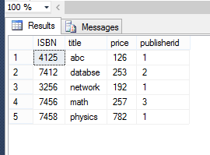 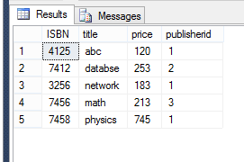

**Ques 12:**

select book.ISBN,book.title,book.price from book join author_book on book.ISBN=author_book.ISBN join author on author_book.authorid=author.authorid where author.address='Dhaka'

Output:

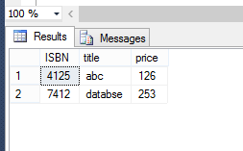

**Ques 13:**

update book set price=price*1.05 where publisherid in (select publisherid from publisher where paddress='dhaka')

select * from book

Output:

Before Update: After Update:

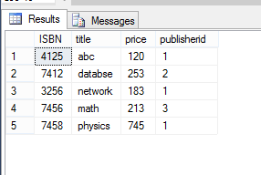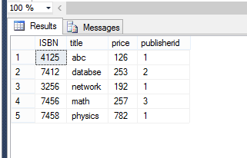

**Ques 14:**

select book.ISBN,book.title from book join author_book on book.ISBN=author_book.ISBN join author on author_book.authorid=author.authorid where author.author_name='jhon'

Output:

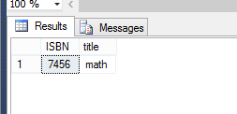

**Ques 15:**

select price from book where title='physics'

Output:

